Robbie Macky

DTEC502 Practical Assessment – SQL Test

1.

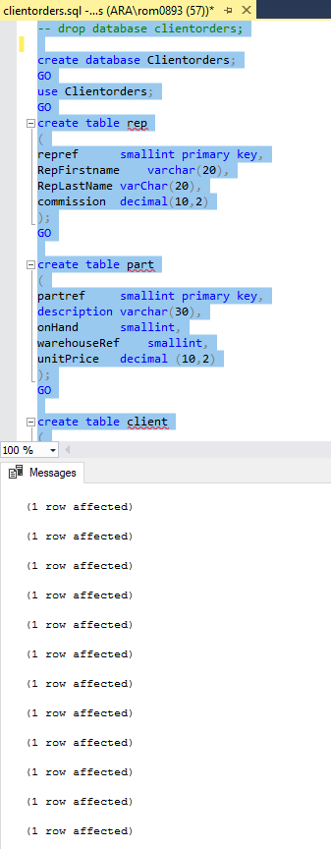

2.

SELECT firstname, lastname, city

FROM [dbo].[client]

WHERE city = 'Dunedin'

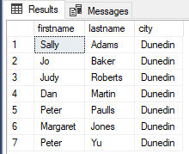

3.

SELECT firstname, lastname

FROM [dbo].[client]

WHERE lastname LIKE 'J%'

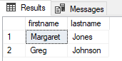

4.

SELECT firstname, lastname, balance

FROM [dbo].[client]

WHERE balance > 50 and balance < 150

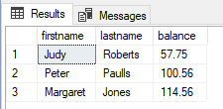

5.

SELECT firstname, lastname, city

FROM [dbo].[client]

WHERE firstname = 'Mary' and lastname = 'Nelson'

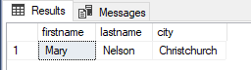

6.

SELECT firstname, lastname, balance, city

FROM [dbo].[client]

WHERE balance < 200 and city = 'Dunedin'

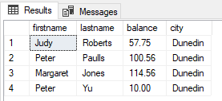

7.

SELECT custref, creditlimit, balance, (creditlimit-balance) AS NewBalance

FROM [dbo].[client]

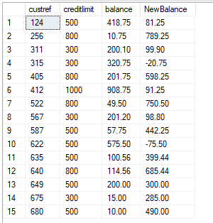

8.

SELECT orderref, partref, quantity, quotedPrice, quantity*quotedPrice AS LineTotal

FROM [dbo].[orderline]

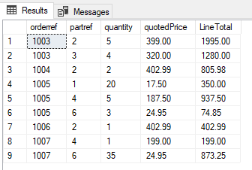

9.

SELECT *

FROM [dbo].[custorder]

WHERE orderdate > '1999-6-1'

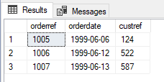

10.

SELECT city, count([city]) AS Number_in_each_city

FROM [dbo].[client]

GROUP BY [city]

HAVING count(city) > 3

ORDER BY count(city) ASC

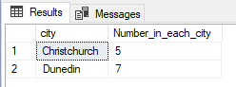

11.

SELECT repref, SUM(balance) AS Total_balance

FROM [dbo].[client]

GROUP BY repref

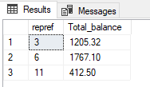

12.

SELECT city, MAX(balance) AS Maximum_balance

FROM [dbo].[client]

GROUP BY city

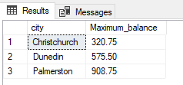

13.

SELECT firstname + ' ' + lastname AS Client_name, RepFirstname + ' ' + RepLastName AS Rep_Name

FROM [dbo].[client], [dbo].[rep]

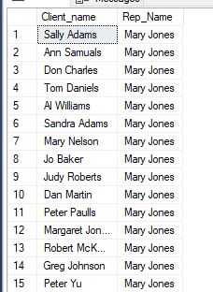

14.

SELECT orderref, firstname, lastname, orderdate

FROM [dbo].[client], [dbo].[custorder]

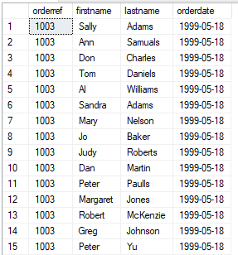

15.

SELECT orderref, description, onHand

FROM [dbo].[part], [dbo].[orderline]

WHERE orderref = '1007'

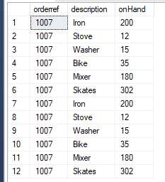

16.

SELECT orderref, description, quotedPrice, quantity

FROM [dbo].[part], [dbo].[orderline]

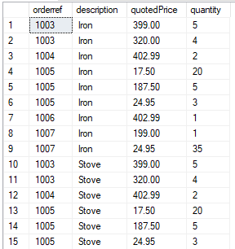

17.

SELECT orderref, description, quotedPrice, quantity

FROM [dbo].[part], [dbo].[orderline]

WHERE quotedPrice > 200

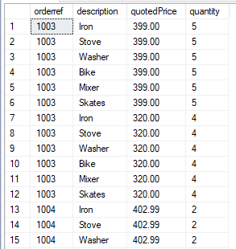

18.

SELECT orderdate, firstname, lastname, description, unitPrice

FROM [dbo].[orderline], [dbo].[client], [dbo].[custorder], [dbo].[part]S

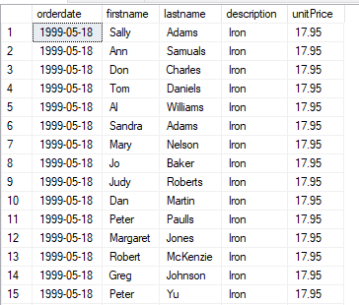

19.

SELECT orderdate, firstname, lastname, description, unitPrice

FROM [dbo].[orderline], [dbo].[client], [dbo].[custorder], [dbo].[part]

WHERE orderdate > '1999-6-10'

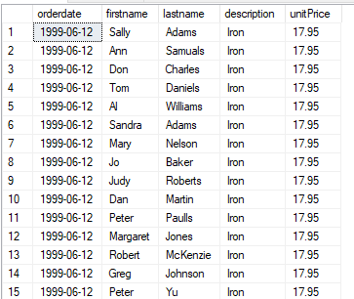

20.

SELECT orderdate, firstname, lastname, RepFirstname, RepLastName, description

FROM [dbo].[orderline], [dbo].[client], [dbo].[custorder], [dbo].[part], [dbo].[rep]

